ECA0302 – SIGNALS AND SYSTEMS
NAME: RAGAVARSHINI R
REG.NO: 192512027
CO3 - EXP -09
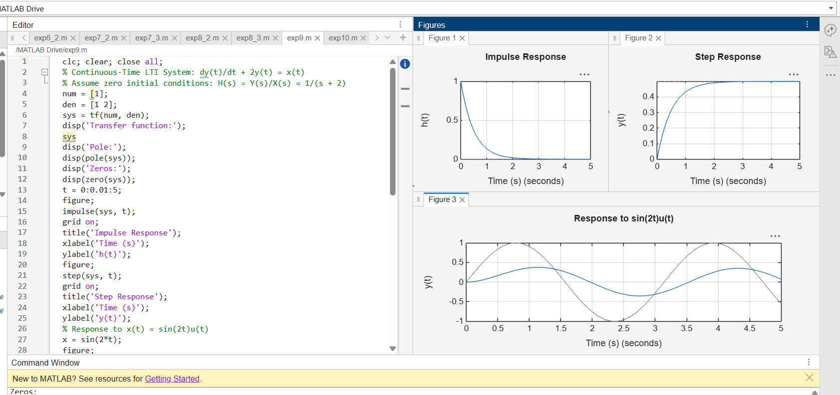
EXP-10